
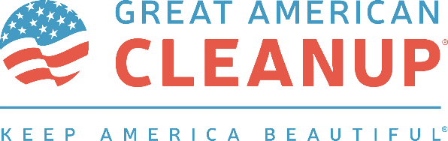

ADULT VOLUNTEER AGREEMENT | LIABILITY RELEASE & WAIVER | PHOTO RELEASE
In consideration of permission to participate in the Clean Up Akron Month/Great American Cleanup™ volunteer program I, intending to be legally bound, hereby, for myself, my heirs, executors, representatives, assigns, and administrators, voluntarily assume all risks of accident or injury and release and forever discharge Keep Akron Beautiful, the City of Akron, their present and former partners, officers, directors, shareholders, members, agents, employees, servants, predecessors, successors, assigns, parent companies, subsidiaries, related companies, affiliates, insurers, attorneys, grantees, assigns, transferees, representatives, and agents from any and all liability for bodily injury or property damage of any kind sustained in association with participation in the program, whether such bodily injury or property damage is caused by the negligence of Keep Akron Beautiful, the City of Akron, or their present and former partners, officers, directors, shareholders, members, agents, employees, servants, predecessors, successors, assigns, parent companies, subsidiaries, related companies, affiliates, insurers, attorneys, grantees, assigns, transferees, representatives, and/or or agents, or otherwise.
I hereby grant Keep Akron Beautiful permission to use my name, image, and likeness in a photograph, video, and/or other digital media (collectively “Media”) in all of its publications, including web-based publications, without payment or other form of consideration. I hereby irrevocably authorize Keep Akron Beautiful to edit, alter, copy, exhibit, publish, or distribute this Media for any lawful purpose.
I covenant and agree to indemnify and hold harmless Keep Akron Beautiful, the City of Akron, their present and former partners, officers, directors, shareholders, members, agents, employees, servants, predecessors, successors, assigns, parent companies, subsidiaries, related companies, affiliates, insurers, attorneys, grantees, assigns, transferees, representatives, and/or agents, from, against, and in respect of any and all claims, liabilities, obligations, losses, costs, expenses, penalties, fines, judgments, and damages (including amounts paid in settlement ,costs of investigation, and reasonable attorneys’ fees and/or expenses) with respect to any claim, liability, obligation, loss, cost, expense, penalty, fine, judgment, and/or damage (as further defined herein) relating to, resulting from, and/or arising from my participation in the Clean Up Akron Month volunteer program. I further agree to abide by all applicable rules and regulations promulgated by Keep Akron Beautiful.

__________________________________ ________________________________
Witness Participant Signature

__________________________________ ________________________________
Witness Participant Printed Name

__________________________________ __________________________, 2026
Volunteer Daytime Phone Number Date

